

# 

### Semester One Examination, 2016

### Question/Answer Booklet

# MATHEMATICS

**APPLICATIONS**

**UNIT 3**

## Section Two:

## Calculator-assumed

**Name**

**Teacher**

## Time allowed for this section

Reading time before commencing work: ten minutes

Working time for section: one hundred minutes

## Materials required/recommended for this section

***To be provided by the supervisor***

This Question/Answer Booklet

Formula Sheet (retained from Section One)

***To be provided by the candidate***

Standard items: pens (blue/black preferred), pencils (including coloured), sharpener, correction fluid/tape, eraser, ruler, highlighters

Special items: drawing instruments, templates, notes on two unfolded sheets of A4 paper, and up to three calculators approved for use in the WACE examinations

## Important note to candidates

No other items may be taken into the examination room. It is **your** responsibility to ensure that you do not have any unauthorised notes or other items of a non-personal nature in the examination room. If you have any unauthorised material with you, hand it to the supervisor **before** reading any further.

## Structure of this paper

|  |  |  |  |  |  |
| --- | --- | --- | --- | --- | --- |
| Section | Number of questions available | Number of questions to be answered | Working  time (minutes) | Marks available | Percentage of exam |
| Section One:  Calculator-free | 7 | 7 | 50 | 50 | 35 |
| Section Two:  Calculator-assumed | 12 | 12 | 100 | 100 | 65 |
|  | | | **Total** | 150 | 100 |

## Instructions to candidates

1. The rules for the conduct of examinations are detailed in the school handbook. Sitting this examination implies that you agree to abide by these rules.
2. Write your answers in this Question/Answer Booklet.
3. You must be careful to confine your response to the specific question asked and to follow any instructions that are specified to a particular question.
4. Spare pages are included at the end of this booklet. They can be used for planning your responses and/or as additional space if required to continue an answer.

* Planning: If you use the spare pages for planning, indicate this clearly at the top of the page.
* Continuing an answer: If you need to use the space to continue an answer, indicate in the original answer space where the answer is continued, i.e. give the page number. Fill in the number of the question that you are continuing to answer at the top of the page.

1. **Show all your working clearly**. Your working should be in sufficient detail to allow your answers to be checked readily and for marks to be awarded for reasoning. Incorrect answers given without supporting reasoning cannot be allocated any marks. For any question or part question worth more than two marks, valid working or justification is required to receive full marks. If you repeat any question, ensure that you cancel the answer you do not wish to have marked.
2. It is recommended that you **do not use pencil**, except in diagrams.
3. The Formula Sheet is **not** to be handed in with your Question/Answer Booklet.

Section Two: Calculator-assumed 65% (100 Marks)

This section has**twelve (****12)** questions. Answer **all** questions. Write your answers in the spaces provided.

Working time for this section is 100 minutes.

Question 8 (7 marks)

The number of votes still to count at the end of an election decreased by 72 every minute after 6 pm. At 6 pm, 2955 votes still needed counting.

(a) Show that by 6:02 pm, 2811 votes still needed counting. (1 mark)

(b) Deduce a non-recursive rule for , the number of votes still needing counting n minutes after 6 pm. (2 marks)

(c) Determine how many votes still needed counting at 6:30 pm. (1 mark)

(d) At 6:30 pm, counting slowed so that only 36 votes were processed every minute. Determine the time, to the nearest minute, that counting finished. (3 marks)

Question 9 (8 marks)

(a) Describe a suitable method to organise and display data when investigating the existence of an association between two categorical variables. (2 marks)

(b) A class was set a task to investigate whether an association exists between the distance a student lived from school and the number of times they were late in a term.

(i) What **type** of graph would be appropriate to display data collected? (1 mark)

(ii) What statistical measure would be useful to calculate in order to determine whether an association existed? (1 mark)

(iii) One student designed the questionnaire shown below. Comment on the appropriateness of their design for this investigation. (2 marks)

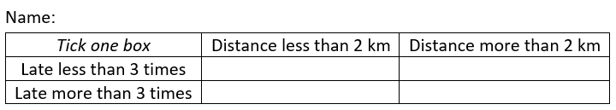

(iv) A student carried out the investigation, found that a moderate negative association existed, and concluded that frequent lateness was caused by living close to the school. Comment on their conclusion. (2 marks)

Question 10 (8 marks)

A media company sought responses from the general public to the question "*How much trust do you have in the following for information about asylum seekers?".* The company were investigating whether the source of information was associated with the degree of trust the general public placed in the information about asylum seekers.

The responses are summarised in the table below.

|  |  |  |  |
| --- | --- | --- | --- |
|  | Degree of trust in asylum seeker information | | |
| Information source | Some trust | Little trust | Not sure |
| Politicians | 27 | 117 | 16 |
| The media | 25 | 84 | 11 |
| Doctors | 99 | 61 | 20 |
| Churches | 54 | 80 | 16 |

(a) Name the explanatory and response variables for this investigation. (2 marks)

(b) Complete the table of percentages below, rounding to the nearest whole number, so that it can be used to identify whether the source of information is associated with the degree of trust the general public place in the information. (4 marks)

|  |  |  |  |
| --- | --- | --- | --- |
|  | Degree of trust in information | | |
| Information source | Some trust | Little trust | Not sure |
| Politicians |  |  |  |
| The media |  |  |  |
| Doctors |  |  |  |
| Churches |  |  |  |

(c) Comment on whether this data provides any evidence that the source of information is associated with the degree of trust placed in the information about asylum seekers.

(2 marks)

Question 11 (9 marks)

Sequence T is defined given by .

(a) Use the recursive rule to complete the table below, rounding values to one decimal place. (2 marks)

|  |  |  |  |  |  |  |
| --- | --- | --- | --- | --- | --- | --- |
| n | 1 | 2 | 3 | 4 | 5 | 6 |
|  | 50 |  |  |  |  |  |

(b) Graph the first six terms of sequence T on the axes below. (2 marks)

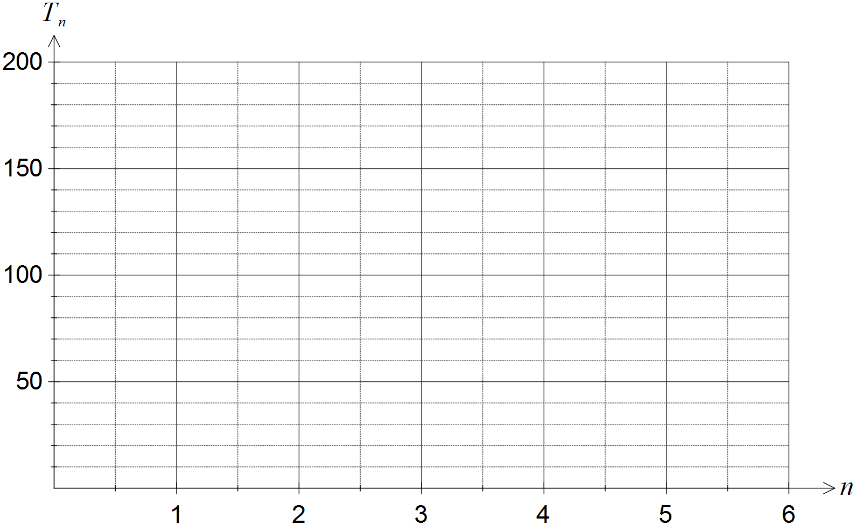

The first three terms of the geometric sequence U are 200, 160 and 128.

(c) Deduce a rule for the nth term of sequence U. (2 marks)

(d) Determine . (1 mark)

(e) Determine the largest value of n so that , justifying your answer. (2 marks)

Question 12 (8 marks)

The daily customer satisfaction index was measured by an online business over a period of ten consecutive days and the data collected is shown in the table below.

|  |  |  |  |  |  |  |  |  |  |  |
| --- | --- | --- | --- | --- | --- | --- | --- | --- | --- | --- |
| Day (d) | 1 | 2 | 3 | 4 | 5 | 6 | 7 | 8 | 9 | 10 |
| CS Index (s) | 92.1 | 91.2 | 90.6 | 88.9 | 88.1 | 87.7 | 87.4 | 86.6 | 85.4 | 85.1 |

(a) Plot the above data on the axes below. (2 marks)

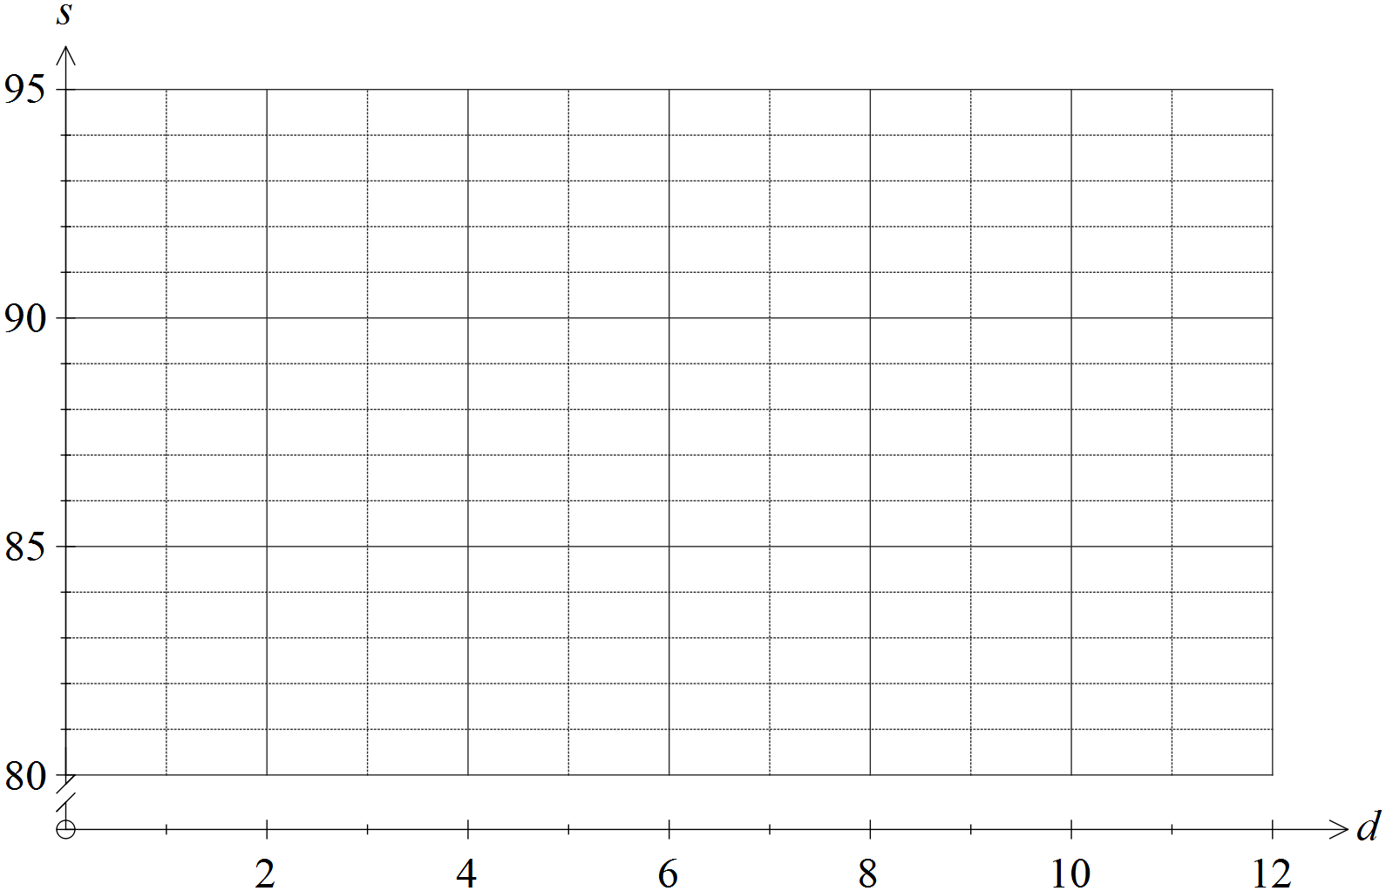

(b) Determine the equation of the least-squares line that models the linear relationship between the day number and the customer satisfaction index. (2 marks)

(c) Draw the least-squares line on the axes above. (2 marks)

(d) Predict the customer satisfaction index for day 11. (1 mark)

(e) Explain why a prediction for the customer satisfaction index for day 15 should be treated with caution. (1 mark)

Question 13 (9 marks)

A business has branches in six cities. The table below shows the time, in minutes, it takes for a package received at one branch to be transported to a branch in another city, where a direct route exists.

|  |  |  |  |  |  |
| --- | --- | --- | --- | --- | --- |
| Q | 40 |  |  |  |  |
| R | - | 50 |  |  |  |
| S | - | 25 | 30 |  |  |
| T | 30 | 35 | - | 25 |  |
| U | 25 | - | - | 65 | 35 |
|  | P | Q | R | S | T |

(a) Construct a weighted graph to show this information, using the cities placed below.

(3 marks)

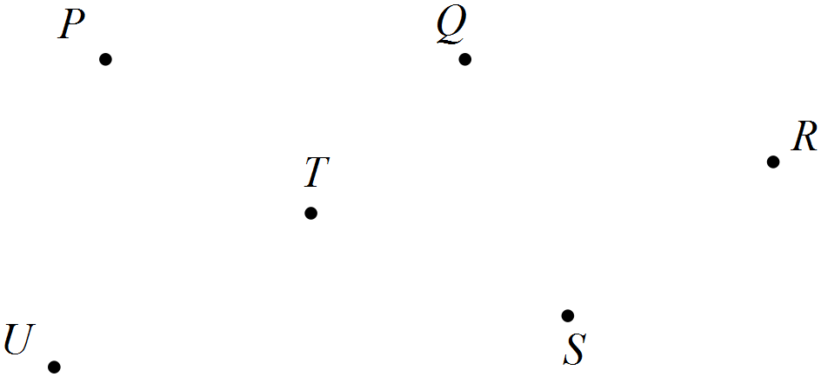

(b) Determine the shortest transport time for a package to travel from

(i) P to S. (1 mark)

(ii) Q to U. (1 mark)

(c) A document needs to be sent from branch U via branch R, where a customer will sign the document, to branch P. Determine the minimum transport time for the document to make this journey, listing all branches on the way. (2 marks)

(d) Another business document requires signing by the manager of each branch. In planning a route for this document, would finding a Eulerian trail be more appropriate than finding a Hamiltonian trail? Explain your answer. (2 marks)

Question 14 (10 marks)

The data in the table below shows the weekly advertising spend (A), in thousands of dollars, and the number of new clients (C) joining a weight loss program during that week in a large city.

|  |  |  |
| --- | --- | --- |
| Week | Advertising spend (A) | New clients (C) |
| 1 | 8.6 | 26 |
| 2 | 9.5 | 31 |
| 3 | 12.2 | 32 |
| 4 | 10.4 | 33 |
| 5 | 12.6 | 34 |
| 6 | 7.3 | 22 |
| 7 | 13.4 | 40 |
| 8 | 9.5 | 32 |
| 9 | 11.6 | 38 |
| 10 | 13.2 | 35 |
| 11 | 10.5 | 31 |

The director of the weight loss program wanted to know if increased advertising spend was associated with a larger number of new clients in a week.

(a) State the explanatory and response variables. (1 mark)

(b) Graph the data on your calculator and use features of the graph to explain whether there is evidence of a linear association between A and C. (2 marks)

(c) Calculate the correlation coefficient between A and C. (1 mark)

(d) Determine what percentage of the variation in A can be explained by the variation in C.

(1 mark)

(e) Determine the equation of the least-squares line that models the relationship between A and C. (2 marks)

(f) If no money was spent on advertising during a week, is the weight loss program likely to attract any new clients? Explain your answer. (2 marks)

(g) Determine the average increase in the number of new clients the weight loss program can expect for every additional $1 000 spent on advertising in any given week. (1 mark)

Question 15 (7 marks)

A fish farmer initially stocked a tank with 50 small fish. At the end of each month, the farmer caught some of the largest fish and sold them before adding more, smaller fish to the tank.

The number of fish in the tank at the start of the nth month is given by , where.

(a) Use the recurrence relation to state

(i) the number of smaller fish added to the tank each month. (1 mark)

(ii) the percentage of the fish caught and sold each month. (1 mark)

(b) Graph  on the axes below for . (3 marks)

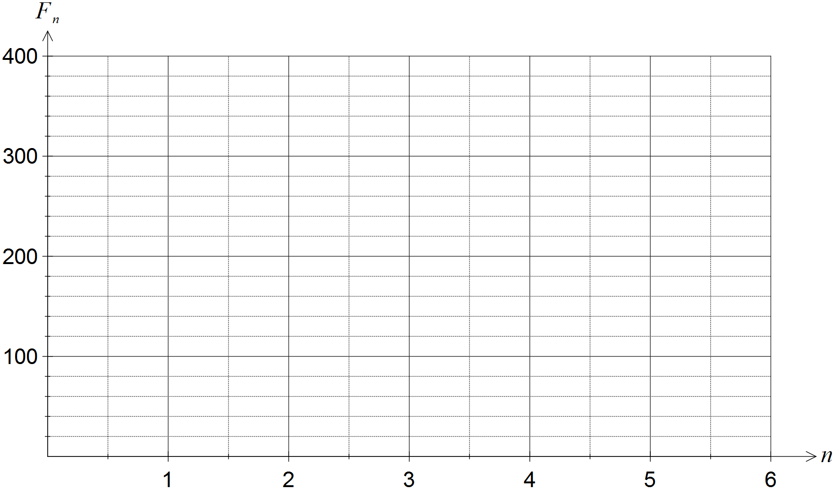

(c) Assuming this model continues, comment on how the number of fish in the tank changes over the next few years. (2 marks)

Question 16 (9 marks)

An airline has flights between six cities as shown in the graph below. Two of the flights are sightseeing flights that return to the city from which they departed.

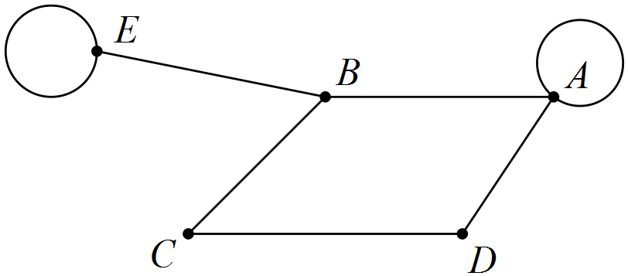

(a) Determine M, the adjacency matrix for this graph. (3 marks)

(b) Calculate and explain the significance of the elements in this matrix that are zero.

(3 marks)

(c) Determine the number of zero elements in the matrix  and explain their significance in terms of specific flight(s). (3 marks)

Question 17 (8 marks)

From observations of a random sample of 236 blackbirds, the equation of the least-squares line that models the relationship between the wing span (s, measured in centimetres) and the mass (m, measured in grams) of blackbirds was found to be . The coefficient of determination between the variables was 0.79.

(a) State the percentage of the variation in wing span of blackbirds that can be explained by the variation in their mass and comment on the strength of the association. (2 marks)

(b) Calculate the correlation coefficient between s and m, using the fact that the direction of the association is positive. (2 marks)

(c) Predict the wing span of a blackbird with a mass of 98 grams. (1 mark)

(d) Explain why it is difficult to comment on the reliability of the prediction in (c). (2 marks)

(e) The mean mass of the birds in the sample was 84.8 grams. Determine the mean wing span of birds in the sample. (1 mark)

Question 18 (8 marks)

An art gallery records the value of all artworks at the start of each year for insurance purposes. The first valuation of a picture was $4 800, and at the start of the next two years the picture was valued at $5 040 and $5 292 respectively.

(a) Show that the picture values form a geometric sequence. (2 marks)

(b) Assuming that the value of the picture continues to increase in this way,

(i) calculate the increase in value of the picture during the third year. (2 marks)

(ii) calculate the insurance premium for the picture in the tenth year, if the premium is 2.5% of the value of the picture. (2 marks)

(iii) determine the year in which the insurance premium, still 2.5% of the value of the picture, will first exceed $300. (2 marks)

Question 19 (9 marks)

The vertex H on the graph below represents a hotel and vertices A to E represent tourist attractions. The numbers on the edges of the graph below represent the walking times, in minutes, between the various attractions.

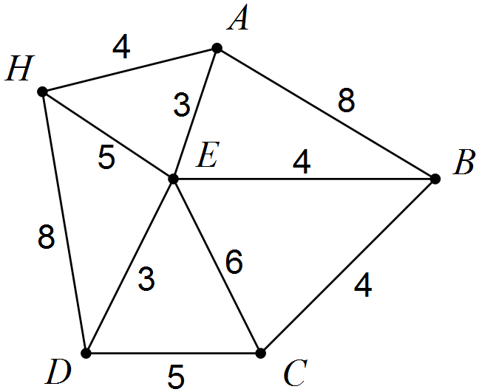

A group of tourists plan to leave the hotel at 10 am and visit all the attractions, spending 15 minutes at each one.

(a) Given that the hotel bus will pick them up from the last attraction they visit,

(i) determine the route they should take that involves the least possible walking time.

(2 marks)

(ii) determine the time the bus should meet them at their last attraction. (2 marks)

(b) One member of the group knows a little about graph theory and suggests that the route that the group plan should be a Hamiltonian cycle.

(i) Explain what is meant by a Hamiltonian cycle. (2 marks)

(ii) Determine the Hamiltonian cycle the group of tourists should walk and state the time they will arrive back at their hotel. (3 marks)

Additional working space

Question number: _________

Additional working space

Question number: _________

Additional working space

Question number: _________

© 2016 WA Exam Papers. Kennedy Baptist College has a non-exclusive licence to copy and communicate this paper for non-commercial, educational use within the school. No other copying, communication or use is permitted without the express written permission of WA Exam Papers.